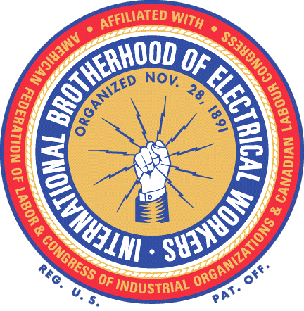

®

What Does This Card Mean?

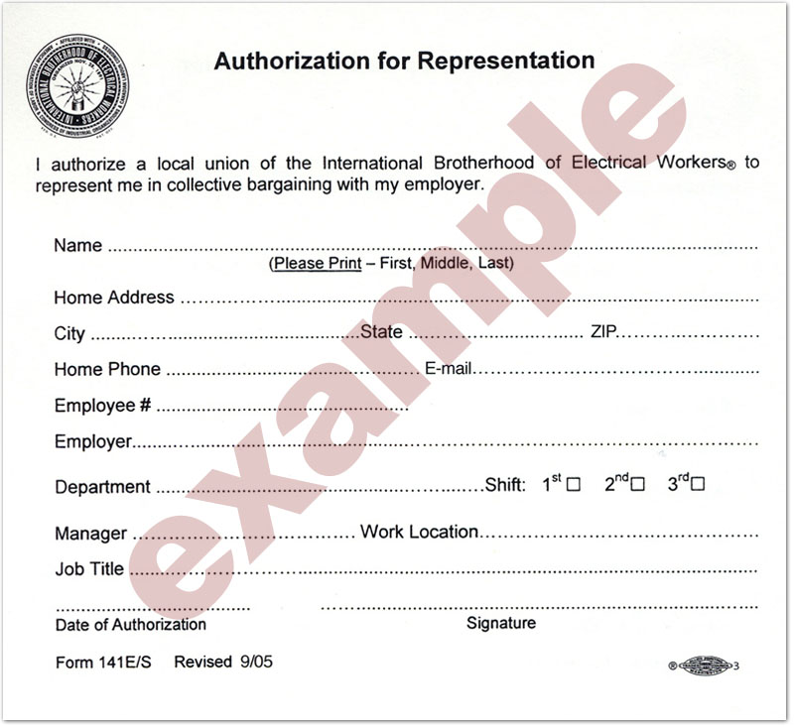

Signing this card means we want a union so we can negotiate a contract with our employer covering our wages, hours, and working conditions. It means we want a process where employees have a meaningful voice in our workplace and are no longer satisfied to leave all the important decisions up to management.

Signing this card gives us the right to decide for ourselves if we want a voice in our workplace and our future.

IBEW
www.ibew.org

Form MD3006

